**Installing Octave on Mac OS X (10.10 Yosemite and 10.9 Mavericks)**

**Installing Octave on Mac OS X (10.10 Yosemite and 10.9 Mavericks)**

Mac OS X [has a feature called Gatekeeper](http://support.apple.com/en-us/HT202491) that may only let you install applications from the Mac App Store. You may need to configure it to allow the Octave installer. Visit your System Preferences, click Security & Privacy, and check the setting to allow apps downloaded from Anywhere. You may need to enter your password to unlock the settings page.

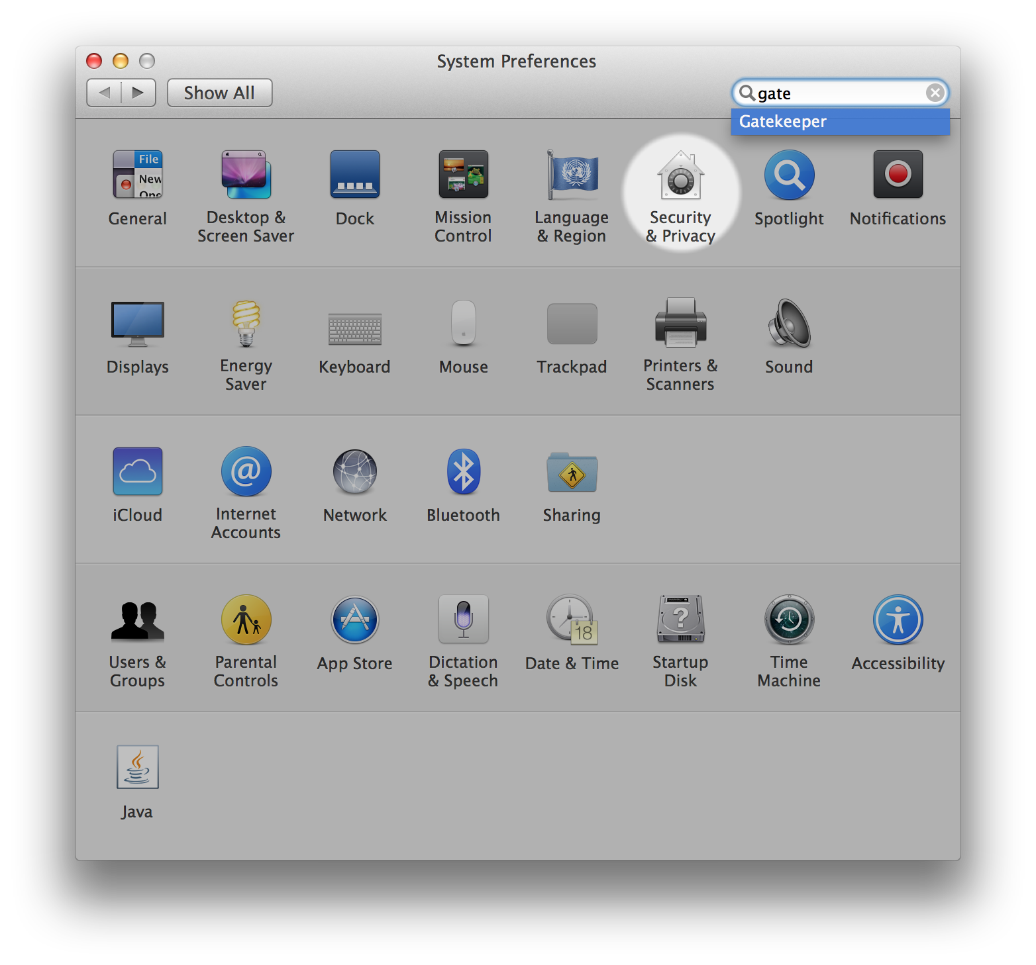

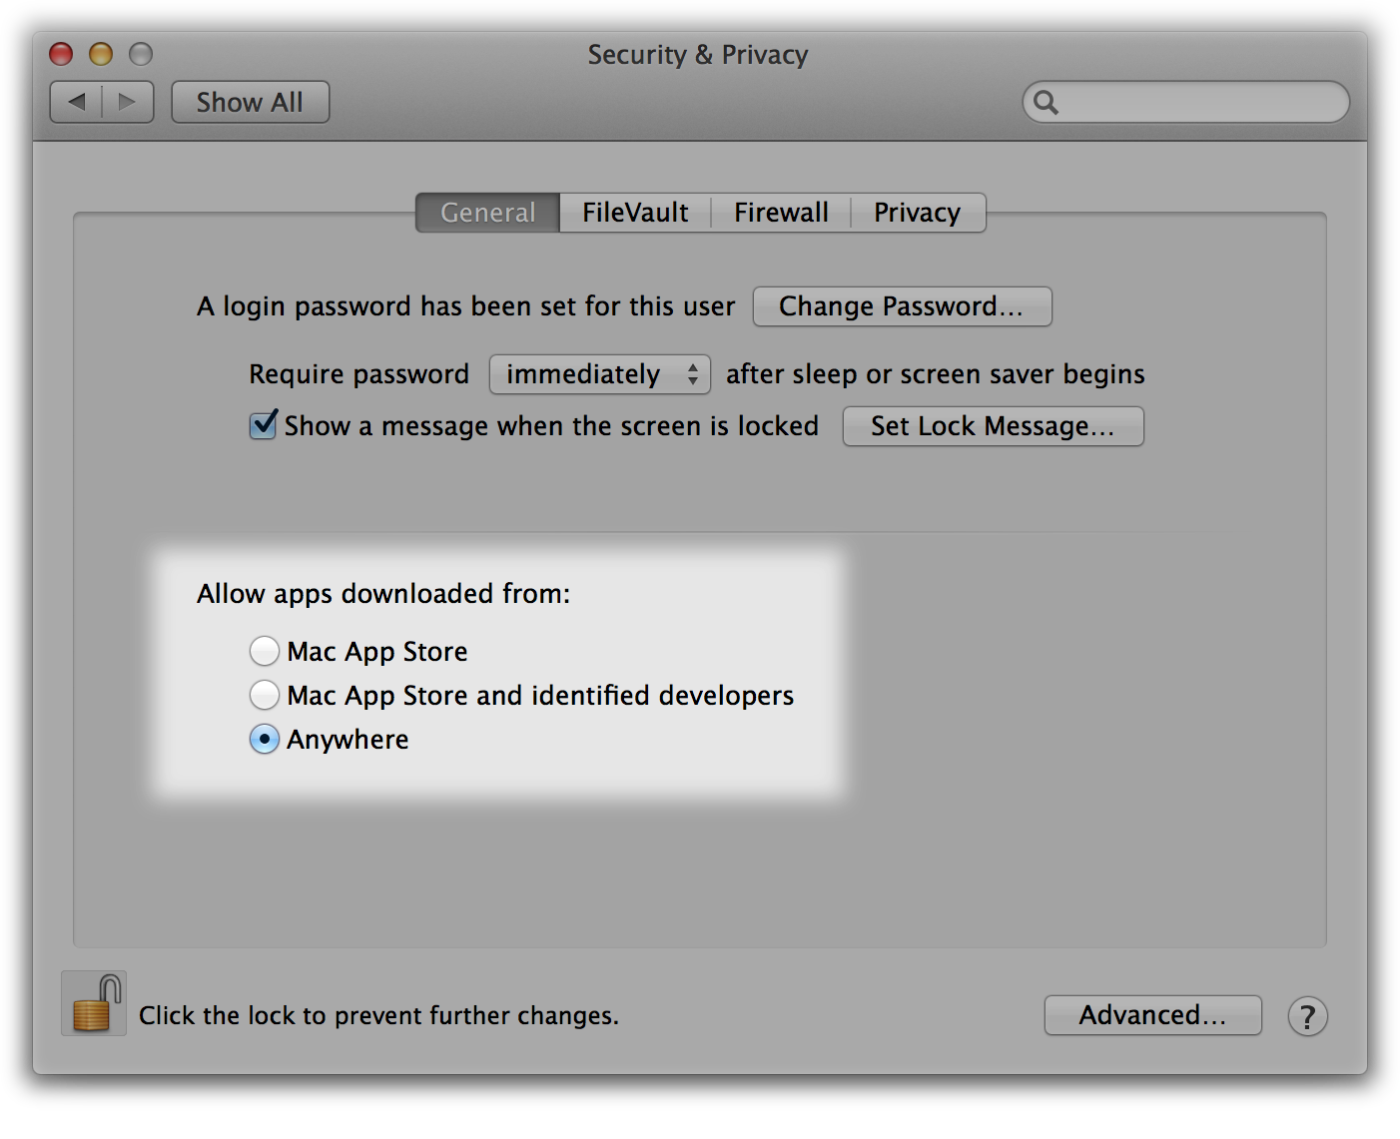

2. Download [the Octave 3.8.0 installer](http://sourceforge.net/projects/octave/files/Octave%20MacOSX%20Binary/2013-12-30%20binary%20installer%20of%20Octave%203.8.0%20for%20OSX%2010.9.1%20%28beta%29/GNU_Octave_3.8.0-6.dmg/download) or the latest version that isn't 4.0.0. The file is large so this may take some time.

3. Open the downloaded image, probably named *GNU_Octave_3.8.0-6.dmg* on your computer, and then open *Octave-3.8.0-6.mpkg* inside.

4. Follow the installer’s instructions. You may need to enter the administrator password for your computer.

5. After the installer completes, Octave should be installed on your computer. You can find *Octave-cli* in your Mac’s Applications, which is a text interface for Octave that you can use to complete Machine Learning’s programming assignments.

Octave also includes an experimental graphical interface which is called *Octave-gui*, also in your Mac’s Applications, but we recommend using *Octave-cli* because it’s more stable.

Note: If you use a package manager (like MacPorts or Homebrew), we recommend you follow [the package manager installation instructions](http://wiki.octave.org/Octave_for_MacOS_X#Package_Managers).

"**Warning:** Do not install Octave 4.0.0"; checkout the "Resources" menu's section of "Installation Issues".